Jacob Richman
Assignment: Module 2 – Visual Paradigm ERD
Database and development use
Due 08/24/26

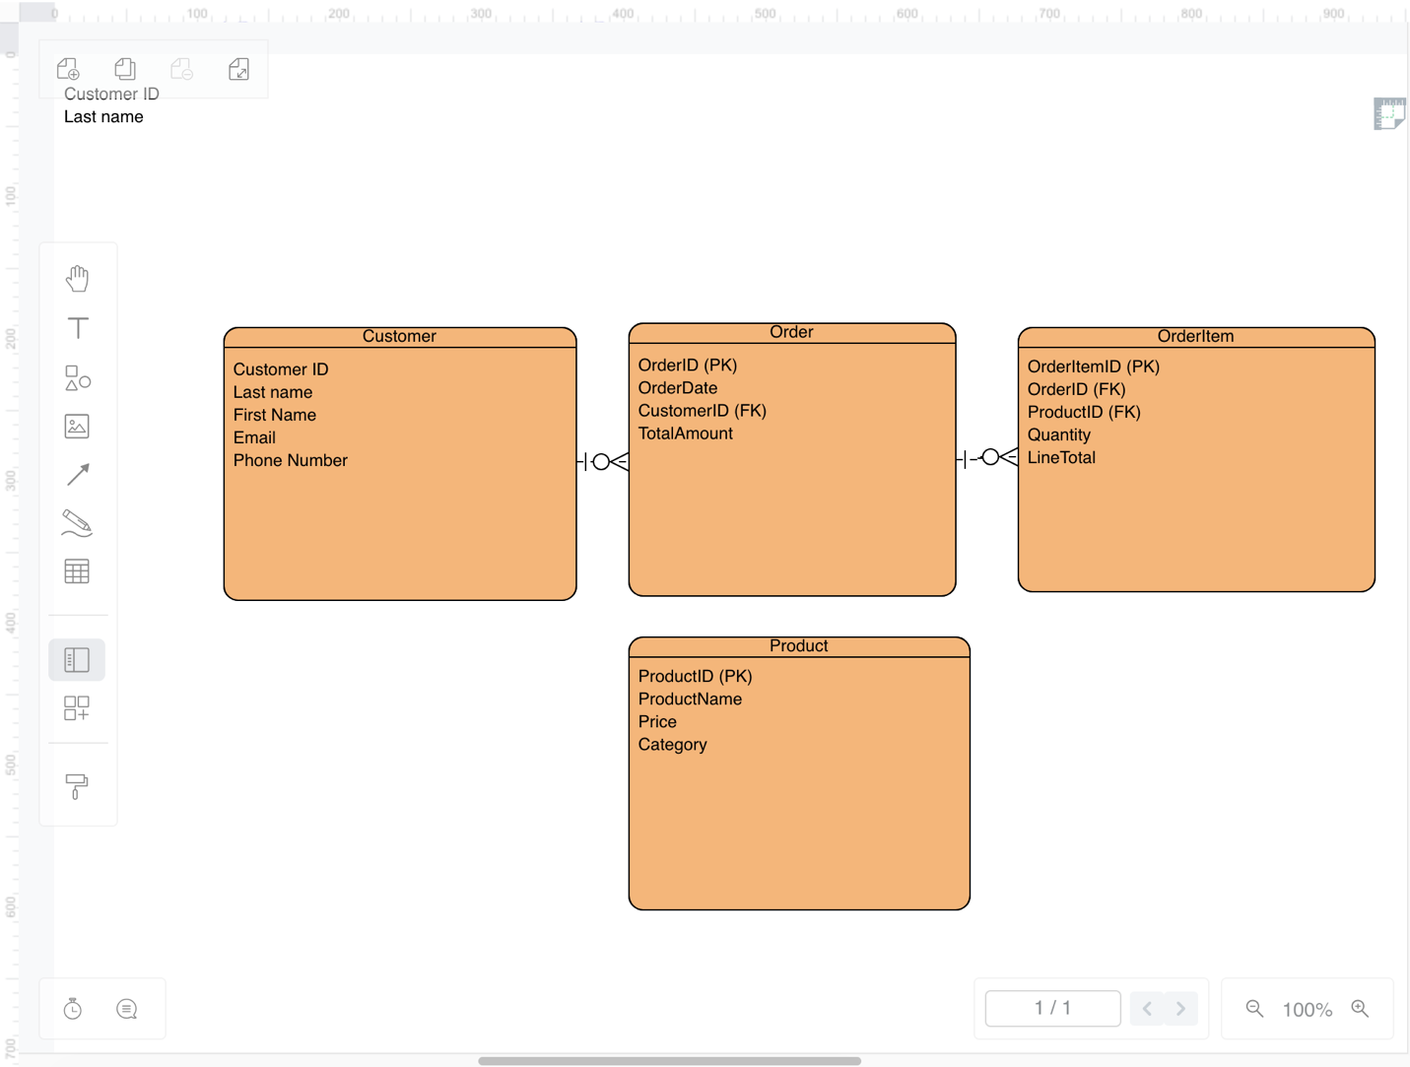
• Customer: Stores customer contact information
• Order: Represents a purchase made by a customer
• Product: Contains details about items available for sale
• OrderItem: Connects orders and products, showing quantity and totals

Describe how your tables connect.
- Customer → Order: One customer can place many orders
- Order → OrderItem: One order can contain many order items
- Product → OrderItem: One product can appear in many order items

This ERD represents a simple ordering system. Customers place orders, orders contain order items, and each order item references a product. The diagram shows how the entities relate using primary and foreign keys.

